The Park at Trowbridge HOA

Annual Meeting Agenda
April 17th, 2012 6:30 PM

- Introductions
- Meeting Call to Order
- Budget Update
- Homeowners Dues
- Neighborhood Watch
- Election of Directors
- Neighborhood Decorum
- Meeting Adjournment

TUESDAY, APRIL 17th
AT 6:30 PM

Annual Homeowner’s Meeting

Unlike all previous meetings it will be held outside our neighborhood in the offices of Atlee Wampler, current HOA treasurer just mile away at:

Perimeter Spine and Rehabilitation Center
7100 Peachtree Dunwoody Rd. NE, Ste. 100
Sandy Springs, GA 30328

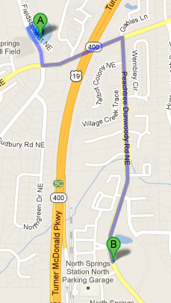
We need at least 2 new directors for the incoming board as well to discuss other issues (see next page).

We need everyone to vote either in person or through a proxy vote (see attached).

We look forward to seeing everyone.

Board of Directors, HOA

The Park at Trowbridge Homeowners Association, Inc.

Certificate of Proxy

The undersigned represents that he/she is a member of the Park at Trowbridge Homeowners Association, Inc. (hereinafter referred to as the “Association”) and is entitled to vote at any and all meetings of the Association. The undersigned hereby revokes all former proxies and powers of attorney to vote at any and all meetings of the association.

The undersigned appoints ________________________________________, with full power of substitution in the event he/she is unable or declines to serve as proxy, to exercise the entire vote of the undersigned and authorizes him/her to vote on my behalf on all duly raised and considered issues upon which I am entitled to vote, including but not limited to election of the Board of Directors, Officers of the Association and the Architectural Control Committee at the special meeting of the members of the Association, or any continuance thereof, to be help Tuesday, April 17th, 2012 at 6:30 PM at the Perimeter Spine and Rehabilitation Center, 7100 Peachtree Dunwoody Rd. NE, Ste. 100, Sandy Springs, GA 30328

Signature of Owner: _________________________________________________

Property Address: _______ Fieldsborn Ct NE, Sandy SPrings, GA 30328

Date: ______ of April, 2012

